
SUSTAINABLE ENERGY INITIATIVE PROJECT

Module 1: How to make Biodiesel?
Part 1: Analysis of Raw Material
OBJECTIVE:
- Analyze the raw material to be used to make biodiesel.
- Assess the quality of the raw material and select the best biodiesel conversion procedure.

Theory:
Biodiesel, an alternative diesel fuel, is made from renewable biological sources such as vegetable oils, animal fats, and microalgal oils. It is biodegradable and nontoxic, has low emission profiles and so is environmentally beneficial¹. One hundred years ago, Rudolf Diesel tested vegetable oil as fuel for his engine². With the advent of cheap petroleum, appropriate crude oil fractions were refined to serve as fuel and diesel fuels and diesel engines evolved together. In the 1930s and 1940s vegetable oils were used as diesel fuels from time to time, but usually only in emergency situations. Recently, because of increases in crude oil prices, limited resources of fossil oil and environmental concerns there has been a renewed focus on vegetable oils and animal fats to make biodiesel fuels². The major components of oils and fats are triacylglycerols (TAG; often also called triglycerides). Chemically, TAG are esters of fatty acids (FA) with glycerol (1,2,3-propanetriol; glycerol is often also called glycerine; The TAG of oils and fats typically contain several different FA. To obtain biodiesel, the oil or fat is subjected to a chemical reaction termed transesterification. In that reaction, the oil or fat is reacted in the presence of a catalyst (usually a base) with an alcohol (usually methanol or short-chain alcohols) to give the corresponding alkyl esters (or for methanol, the methyl esters) of the FA mixture that is found in the raw material. In addition to vegetable oils, animal fats and microalgal oil, other materials such as used frying oils can also be suitable for biodiesel production; however, changes in the reaction procedure frequently have to be made due to the presence of water or free fatty acids (FFA) in the materials³. Special processes are required if the oil or fat contains significant amounts of FFA. Used cooking oils typically contain 2–7% FFA, and animal fats contain 5–30% FFA. When an alkali catalyst is added to these feedstocks, the FFA react with the catalyst to form soap and water as shown in the reaction below:

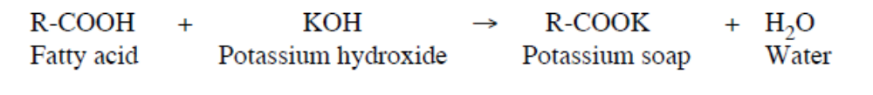
Up to ~5% FFA, the reaction can still be catalyzed with an alkali catalyst, but additional catalyst must be added to compensate for that lost to soap. The soap created during the reaction is either removed with the glycerol or washed out during the water wash. When the FFA level is >5%, the soap inhibits separation of the glycerol from the methyl esters and contributes to emulsion formation during the water wash. For these cases, an acid catalyst such as sulfuric acid can be used to esterify the FFA to methyl esters as shown in the following reaction³:
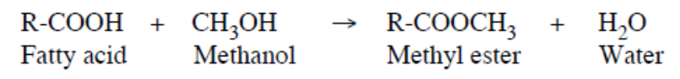
Generally, the fuel quality of biodiesel can be influenced by several factors, including the quality and fatty acid composition of the feedstock, the production process, the other materials used in this process, and postproduction parameters. It is also important to monitor the quality of the feedstocks, which can often be limited to acid value and water contents, tests that are not too difficult³. In the case of vegetable oil that is used for frying foods, the high heat, water, and food products in the fryer can degrade the oil into various byproducts. One byproduct is the development of free fatty acids in the oil. These acids will act to neutralize some of the Sodium Hydroxide used in the biodiesel reaction. Since for example, if the transesterification reaction requires 4 grams of catalyst for every liter of oil, we will need to add extra Sodium Hydroxide to make up for that neutralized by the free fatty acids. More heavily used oil will tend to be more acid, and thus require larger quantities of Sodium Hydroxide than lightly used oil. It is important when making biodiesel to use the proper amount of Sodium Hydroxide for given oil. Too much Sodium Hydroxide can result in a solid soap forming in the reaction vessel, and too little Sodium Hydroxide will result in an incomplete reaction and poor quality fuel. The exact amount of extra Sodium Hydroxide required is determined by a process called titration. To perform the titration, a known solution of Sodium Hydroxide is added to a sample of used oil in measured amounts, until a desired pH shift is seen. Because it is difficult to measure the pH of oil, the oil will first be dissolved in isopropyl alcohol to make testing easier. For this exercise, you will determine the quantity of Sodium Hydroxide needed to make biodiesel from two different oils: one that is heavily used and one that is lightly used.

REAGENTS AND MATERIALS
- Two Samples of vegetable oil: used and inused oil(about 600 ml)
- Ethyl Alcohol, 95%. The alcohol shall give a definite, distinct, and sharp end-point with phenolphthalein and shall be neutralized with alkali to a faint but permanent pink color just before using. (Isopropanol, 99%, may be used as an alternate solvent with crude and refined vegetable oils)
- Phenolphthalein Indicator Solution, (1% in 95% alcohol)
- 250 mL of 0.01 N of Sodium Hydroxide Solution, accurately standardized
- Phthalate Acid of Potassium (KHP)
- Hot plates with stirring rods
- Pipettes graduated to measure 0.2 ml
- Erlenmeyer flask

Diagram of the titration
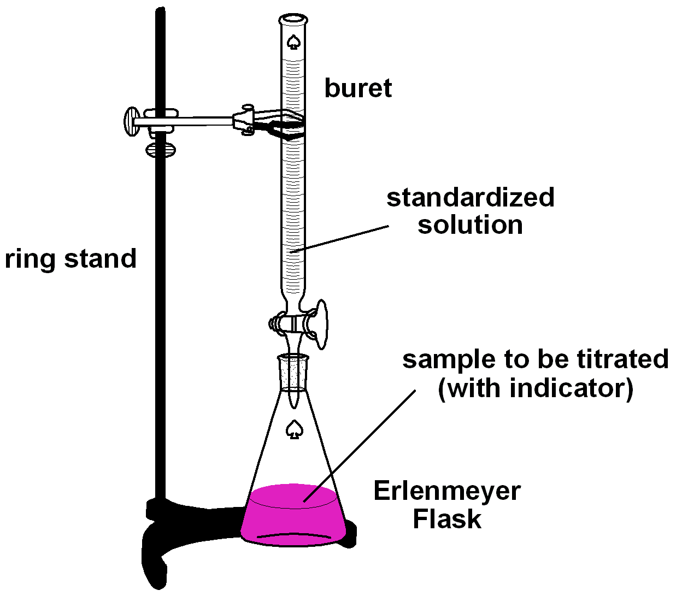
PROCEDURE⁴

Standardization of 0.1 N NaOH solution with KHP:
- Weight the mass of KHP estimated at 250 mL Erlenmeyer flask; add 50 mL of distilled water and swirl the flask until the KHP is dissolve and add 2 drops of phenolphthalein indicator (colorless in acidic solution; pink in basic solution).
- Titrate the KHP solution with de NaOH solution to be standardized. Titration should proceed until the faintest pink persists for 30 sec. after swirling. The color will fade upon exposure to the air (WHY?).
- Make a duplicate determination and calculate the average normality of the NaOH.

Analysis of Oil:
Table 1. Suggested Quantity of Material to Test
Sample, g | Alcohol, mL | Normality Alkali | Free Fatty Acid Range (%)
56.4 ± 0.2 | 50 | 0.1 | 0.0 to 0.2
28.2 ± 0.2 | 50 | 0.1 | 0.2 to 1.0
7.05 ± 0.05 | 75 | 0.25 | 1.0 to 30.0
7.05 ± 0.05 | 100 | 0.25 or 1.0 | 30.0 to 50.0
3.525 ± 0.001 | 100 | 1.0 | 50.0 to 100.0

- Use Table 1 to determine the quantities of oil to be used depending on the content of fatty acids.
- The sample shall be entirely liquid and well mixed before weighing. Then weigh the designated sample size into an oil-sample bottle or Erlenmeyer flask; add to that the specified amount of hot, neutralized alcohol and 2 mL of indicator.
- Shaking vigorously, make the titration with alkali to the appearance of the first permanent pink color of the same intensity as that neutralized alcohol before adding the sample. The color shall for 30 s.
CALCULATION AND Report
- Standardization of NaOH with KHP (Phthalate Acid of Potassium)
The grams of KHP needed for the standardization of the NaOH solution can be calculated with the following equation:
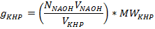
Using g _{KHP}, now can calculate the concentration of NaOH solution:
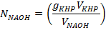
- The free fatty acids is normally reported in percent (%FFA), by weight:
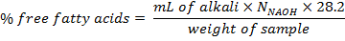
The free fatty acids are also frequently expressed in terms of acid value instead of percent free fatty acids. The acid value is defined as the number of milligrams of KOH necessary to neutralize I g of sample. To convert percent free fatty acids (as oleic) to acid value, multiply the former by 1.99.

Type of Oil | Free Fatty Acid Range  %
Used Oil
Inused Oil

REFERENCES:

- Krawczyk, T., 1996. Biodiesel – alternative fuel makes inroads but hurdles remain. INFORM 7, 801-829.
- Shay, E.G., 1993. Diesel fuel from vegetable oils: status and opportunities. Biomass and Bioenergy 4, 227-242.
- Knothe, G., Gerpen, J., and Khral, J. 2005. The Biodiesel Handbook. AOAS
- ASTM D5555 95 (Reapproved 2006). Standard Test Method for Determination fo Free Acids Contained in Animal, Marine, and Vegetable Fats and Oils Used in Fat Liquors and Stuffing Compounds.

